**Some UNIX commands and Git commands**

**Creating a folder and file using the git bash.**

ls – to list everything in the current directory

cd folder name – change directory

mkdir folder name – make directory – to create a folder in the current directory

touch file name – to create a file in the current folder

1. Default text file
2. Or with preferred extensions

vim or vi file name – it is a default text editor to add content in the file.

1. I or i for insert – helps to write text
2. To exit vim – esc - :wq!

cat file name– to print the content of the file in the terminal

ls -la – to know the dated created, user name, size

rm -r file or folder name – to remove

rm -rf file or folder name – to force delete

cd .. – back to the previous directory

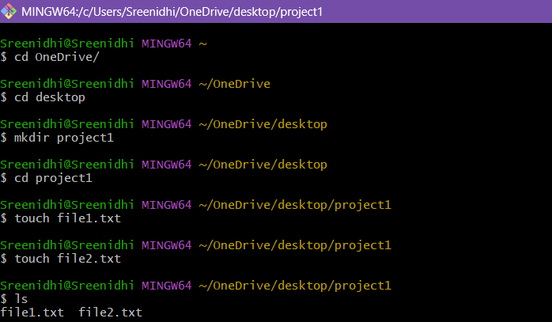

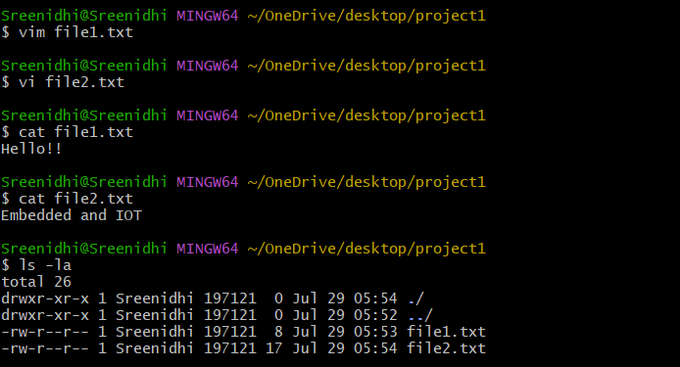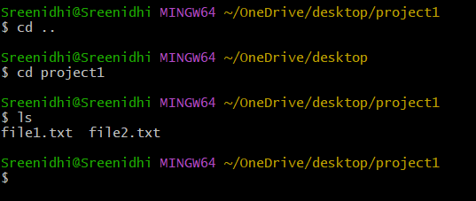

Git file and creating local repository:

Git :

1. Version control system
2. It tracks every change
3. Can be used to time travel
4. Can save the file as git whenever we want with the actual date

git init – normal file to git file – creates empty repo

rm -rf .git – remove git file

git add . – to track the files

git status – to check whether it is tracked

1. Green – tracked
2. Red – untracked

If changes have made in the file after tracking, this process has to be done again.

git commit -m “msg” – to commit changes

git log – to check if the file has got commit

